


Scope and Storyboard for Allianz MI User Front End

Allianz Team, Manchester

By Gareth Levingston

Table of Contents

1. Document Revision History 2
1.1. Document Location 2
1.2. Revision History 2
1.3. Reviewed by 2
1.4. Approvals (please complete ‘name’ column on first draft) 2
1.5. Distribution 2
2. Summary of Scope 3
3. Screen design 3
4. Workflow 3
5. Navigation 3
5.1. Where will the Flow be launched from 3
5.2. Where should the Flow return to 3
6. SQL Tables 3
6.1. Table 3
6.2. Lookup 3
6.3. Field 3
7. Stored Procedures 3
7.1. Fetch 3
7.2. Save 3
8. Document Templates 3
9. Javascript 3

Document Revision History

Document Location
Full File Path
\\Man05sql\Dev\Applications\Flosuite\Scopes\Zurich MI and MI structure enhancements\FL028 Scope and Storyboard Zurich MI User front end.doc

Revision History
Version Number | Revision Date | Summary of Changes | Changes marked | Author
1.0 | 24/02/2012 | First issue | n/a | GQL
2.0 | 28/02/2012 | Alterations from user feedback | Yes | GQL

Reviewed by
Name | Signature | Title | Date of Issue | Version
Lisa Williams |  | Project Manager
Andrea Brown |  | Test Analyst
Mark Jenkinson |  | Project Liaison Officer

Approvals (please complete ‘name’ column on first draft)
Name | Signature or  Date of Approval Email | Title | Date of Issue | Version

Distribution
Name | Title | Date of Issue | Version

Summary of Scope

This scope describes the current MI requirement for Allianz as a client for both Motor and Casualty work types in terms of Field Set with any required pick lists and subsequent data structure changes to accommodate the complete field set.

Also contained is a description to new functionality that will be added to FloCase to accommodate Claimant specific MI

Screen design

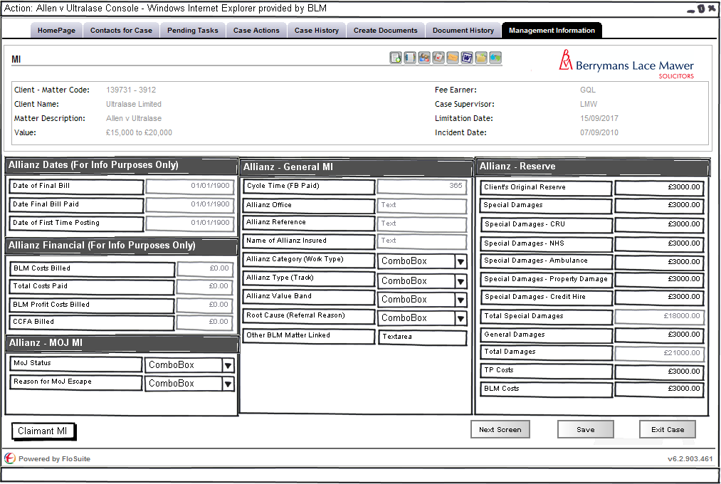

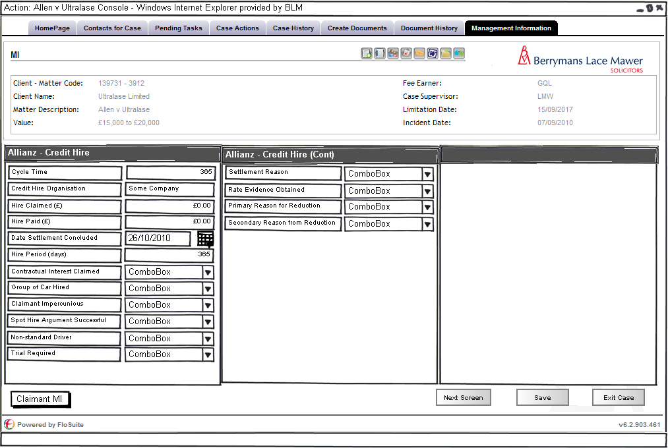

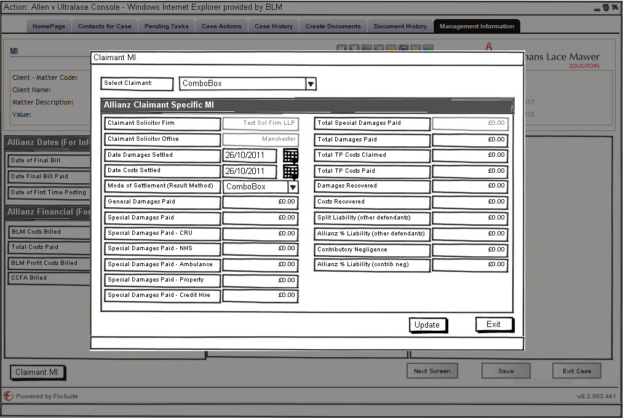
(Screen accessed via new Claimant MI button on the MI Screen)

The above three diagrams show the screen layout designs for the Allianz MI based on the following data provided by the MI team:

Matter Centric MI

Field Name | Format | Expert Field? | Read Only? | Existing MI Field? | Code | Notes
Allianz Office | text | Yes | Yes | Yes | MICFIELD103 | SQL to be provided
Allianz Reference | text | No | Yes | Yes | MIFLD00002
Name of Allianz Insured | text | No | Yes | Yes | AAAAAAAAAA
Allianz Category (Work Type) | picklist | Yes | No | Yes | XWORKTYPE1
Allianz Type (Track) | picklist | Yes | No | Yes | MIFLD00022
Allianz Value Band | picklist | Yes | No | Yes | ValBand
Root Cause (Referral Reason) | picklist | Yes | No | Yes | MIFLD00001
MoJ Status | picklist | Yes | No | No
Reason for MoJ Escape | picklist | Yes | No | Yes | MICFIELD99
Date of Final Bill | date | Yes | Yes | No |  | SQL to be provided
Date Final Bill Paid | date | Yes | Yes | No |  | SQL to be provided
BLM Costs Billed | currency | Yes | Yes | No |  | SQL to be provided
Total Costs Paid | currency | No | Yes | No
BLM Profit Costs Billed | currency | Yes | Yes | No |  | SQL to be provided
CCFA Billed | currency | Yes | Yes | No |  | SQL to be provided
Date of First Time Posting | date | Yes | Yes | No |  | SQL to be provided
Cycle Time (FB Paid) | integer | No | Yes | No
Other BLM Matter Linked | text | Yes | No | No
Client's Original Reserve | currency | Yes | No | No
Total Damages Reserve | currency | No | Yes | Yes | CurrResDam
General Damages Reserve | currency | No | No | Yes | RALDAMAGES
Total Special Damages Reserve | currency | No | Yes | No
Special Damages Reserve | currency | No | No | Yes | IALDAMAGES
Special Damages Reserve - CRU | currency | No | No | Yes | ResCRU
Special Damages Reserve - NHS | currency | No | No | Yes | ResNHS
Special Damages Reserve - Ambulance | currency | No | No | Yes | ResAmb
Special Damages Reserve - Property Damage | currency | No | No | No
Special Damages Reserve - Credit Hire | currency | No | No | No
TP Costs Reserve | currency | No | No | Yes | CurrResTPC
BLM Costs Reserve | currency | No | No | Yes | MICFIELD76
Cycle Time | integer | No | No | Yes | MICFIELD10
Credit Hire Organisation | text | No | No | Yes | MICFIELD91
Hire Claimed (£) | currency | No | No | Yes | MICFIELD92
Hire Paid (£) | currency | No | No | Yes | MICFIELD93
Date Settlement Concluded | date | No | No |  |  | Need Confirmation if this is the same as the date damages settled above.
Hire Period (days) | integer | No | No | Yes | HIREPERIOD
Contractual Interest Claimed | currency | No | No | Yes | ESTCLAIMED
Group of Car Hired | picklist | No | No | Yes | GrpCarHire
Claimant Impercunious | picklist | No | No | No
Spot Hire Argument Successful | picklist | No | No | No
Non-standard Driver | picklist | No | No | No
Trial Required | picklist | No | No | Yes | MICFIELD72
Settlement Reason | picklist | No | No | Yes | LEMNTREASN
Rate Evidence Obtained | picklist | No | No | Yes | EEVIDOBTND
Primary Reason for Reduction | picklist | No | No | Yes | TIONREASON
Secondary Reason from Reduction | picklist | No | No | Yes | IONREASON2

Claimant Centric MI

Field Name | Format | Expert Field? | Read Only? | Existing MI Field? | Code | Notes
Claimant Solicitor Firm | text | No | Yes | No
Claimant Solicitor Office | text | No | Yes | No
Date Damages Settled | Date | No | No | No
Date Costs Settled | Date | No | No | No
Mode of Settlement (Result Method) | picklist | No | No | No
Total Damages Paid | currency | No | No | No
General Damages Paid | currency | No | No | No
Total Special Damages Paid | currency | No | No | No
Special Damages Paid (excluding CRU/NHS, Credit Hire and Property damage) | currency | No | No | No
Special Damages Paid - CRU | currency | No | No | No
Special Damages Paid - NHS | currency | No | No | No
Special Damages Paid - Ambulance | currency | No | No | No
Special Damages Paid - Property Damage | currency | No | No | No
Special Damages Paid - Credit Hire | currency | No | No | No
Total TP Costs Claimed | currency | No | No | No
Total TP Costs Paid | currency | No | No | No
Damages Recovered | currency | No | No | No
Costs Recovered | currency | No | No | No
Split Liability (with respect to other defendants) | picklist | No | No | No
Allianz % Liability (with respect to other defendants) | percentage | No | No | No
Contributory Negligence | picklist | No | No | No
Allianz % Liability (with respect to contrib neg) | percentage | No | No | No

Note: Although some of these field may seem to exist on other MI sets because they need to be specifically associated with an individual Claimant they will need to be defined as brand new MI fields.

This filed set will be defined for the following Group Codes/Client Numbers:
- TBC

Workflow

The following triggers with in the natural flow of a Matter should prompt the user to review the MI on that matter these are as follows:
- Settlement

SQL Tables modifications

Lookup

The following new look ups are required
- Allianz Category
  - CH - Credit Hire
  - DIS - Disease
  - EPFR - EL / PL Fraud
  - EPPI - EL / PL Personal Injury (Excl. Disease)
  - MFR - Motor Fraud
  - MNPI - Motor Non PI (Excl. Credit Hire)
  - MPI - Motor PI (excl. Credit Hire)
  - OTH - Other
  - PDPL - PL Property Damage & Product Liability
  - PROP - Property
- Allianz Type
  - FAS - Fast Track
  - MOJ3 - MoJ Stage 3 Oral Hearing
  - MUL - Multi Track
  - OTH - Other
  - OUT - Outsource
  - PRE - Pre litigation
  - SML - Small Track
- Allianz Value Band
  - A2 - Less than £1,000
  - B2 - £1,000 to £25,000
  - C2 - £25,001 to £100,000
  - D2 - £100,001 to £500,000
  - E2 - More than £500,000
- Root Cause Analysis
  - 0001 - Allianz Breached Protocol
  - 0002 - Liability Dispute - Allianz Position Realistic
  - 0003 - Liability Dispute - Allianz Position Unrealistic
  - 0004 - Allianz Failure To Make Any Offer
  - 0005 - Quantum Dispute - Allianz Position Realistic
  - 0006 - Quantum Dispute - Allianz Position Unrealistic
  - 0007 - Limitation
  - 0008 - Costs Only
  - 0009 - Approval Hearing
  - 0010 - Prosecution
  - 0011 - Other
  - 0012 - Fraud
  - 0013 - Unreasonable Claimant Conduct / Premature Issue
- MoJ Status
  - ESC - Claim Commenced under MoJ and escaped
  - NEV - Never MoJ
  - PRO - Claim Currently in MoJ Process
- MoJ Escape Reason
  - 0001 - Not Applicable
  - 0002 - Denial of Liability
  - 0003 - Allegation of Contributory negligence
  - 0004 - Failure to respond with 15 days on Liabi
  - 0005 - Failure to pay stg1 fixed costs w/i 10dy
  - 0006 - Failure to respond-claimants offer - 15d
  - 0007 - Failure to make an interim payment
  - 0008 - Failure to pay Stg2 fixed costs w/i 10dy
  - 0009 - Allegation of Fraud
  - 0010 - Unsuitable for the process
  - 0011 - Quantum found to exceed MoJ limit
  - 0012 - Minor - Interim Payment
  - 0013 - Premature issue
- Mode of Settlement
  - MSET0001 - Claim discontinued
  - MSET0002 - Drop hands offer agreed
  - MSET0003 - Costs inclusive offer agreed
  - MSET0004 - Part 36 offer accepted
  - MSET0005 - Trial / Hearing: Won - limitation
  - MSET0006 - Trial / Hearing: Won - causation
  - MSET0007 - Trial / Hearing: Won - quantum
  - MSET0008 - Trial / Hearing: Lost - limitation
  - MSET0009 - Trial / Hearing: Lost - causation
  - MSET0010 - Trial / Hearing: Lost - quantum
  - MSET0011 - Appeal: Won - limitation
  - MSET0012 - Appeal: Won - causation
  - MSET0013 - Appeal: Won - quantum
  - MSET0014 - Appeal: Lost - limitation
  - MSET0015 - Appeal: Lost - causation
  - MSET0016 - Appeal: Lost - quantum
- Group of Car Hired
  - LIST TBC
- Spot Hire Argument Successful
  - SPHIRE0001 - Yes
  - SPHIRE0002 - No
  - SPHIRE0003 - N/A
- Non-standard Driver
  - Yes
  - No
  - Not Known
- Trial Required
  - Yes
  - No
- Settlement Reason
  - Discontinued
  - Negotiation
  - Trial Won
  - Trial Lost
  - Judgment Sum Paid
  - Returned to Client
- Rate Evidence Obtained
  - Own Evidence
  - Negotiated settlement
  - External Evidence
  - Autofocus
- Primary Reason for Reduction
  - Period
  - Rate
  - Need
  - General Failure to Mitigate
  - Claimant was VAT registered
  - Enforceability
  - Liability
  - Additional extras not allowed in full
  - Invoice improperly calculated
  - Other
- Secondary Reason from Reduction
  - Period
  - Rate
  - Need
  - General Failure to Mitigate
  - Claimant was VAT registered
  - Enforceability
  - Liability
  - Additional extras not allowed in full
  - Invoice improperly calculated
  - Other

/tmp/lo/0000.doc

